**Application Programming assignment 1 testing**

**By: Nikoloz Muladze**

**PART 1)**

**Preview:**

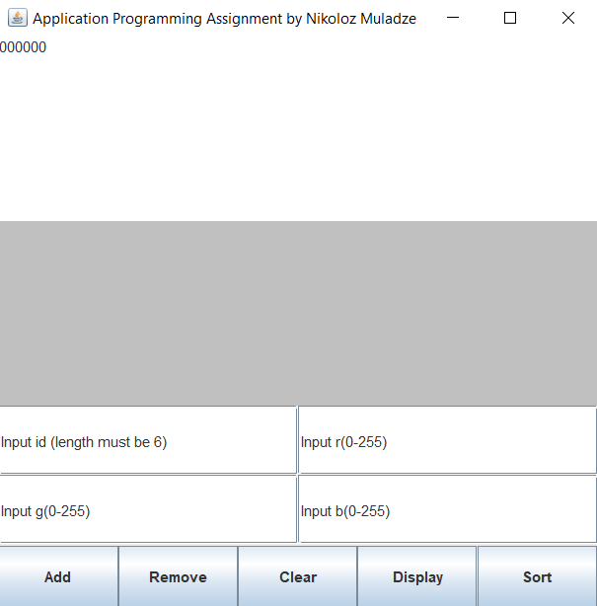

Input id (length must be 6) is a field where we append IDs to the text area

The rest of the fields are for RGB values.

The middle gray line is for exception handling, if something goes wrong or any type of action is performed it outputs what happened.

1. **Add an ID to the list & b) Display all the IDs from the list**

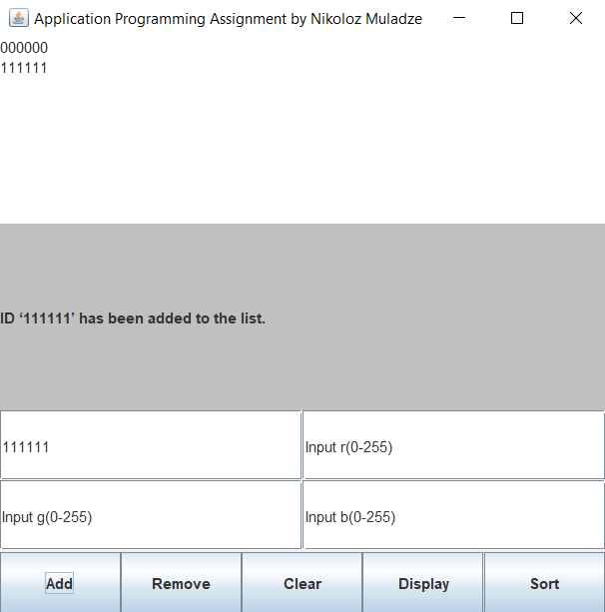

Action performed: typed in 111111 in the text field and pressed Add button, it is then appended to the list above and action is shown in the gray.

1. **Remove from the list all matching occurrences of an ID entered in the text field.**

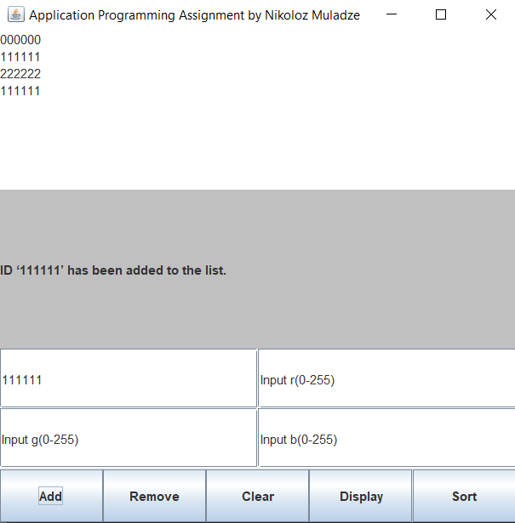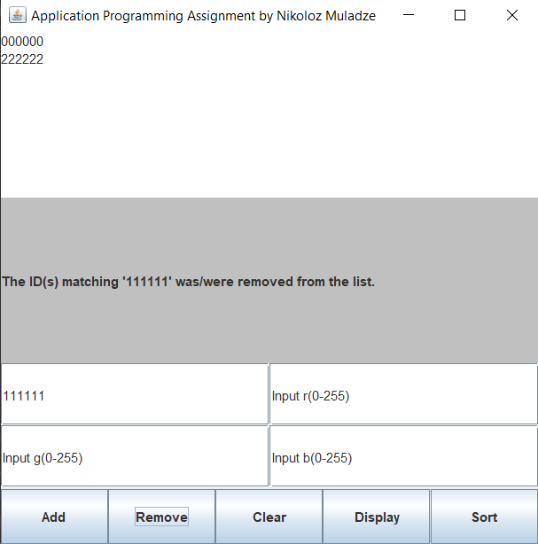

Action performed: added 222222 & 111111, then pressed remove while 111111 was inside input field and all occurrences of 111111 in the list were removed.

1. **Sort the list of IDs in ascending order and display the contents of the list.**

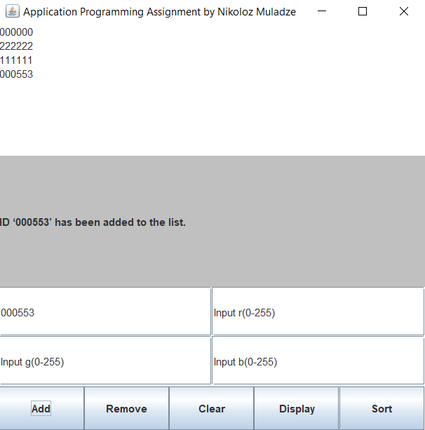

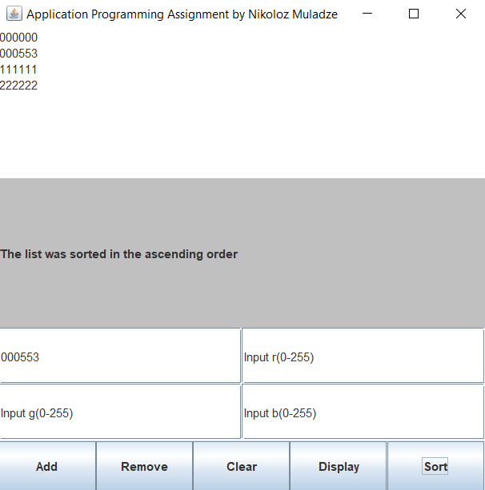

Action performed: added 111111 & 000553 ids to the list, then pressed Sort button and it sorted the list in an ascending order as stated in the gray area.

1. **Clear the list.**

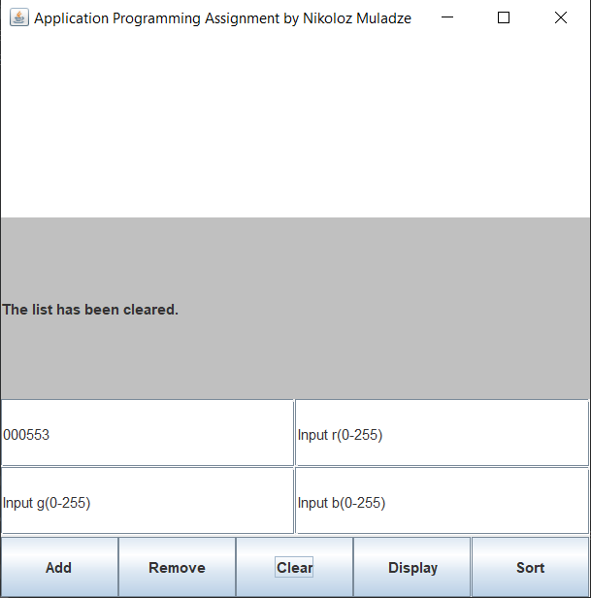

Action performed: pressed Clear button and all the IDs were removed from the list.

**If ID isn’t of 6 digits following will happen:**

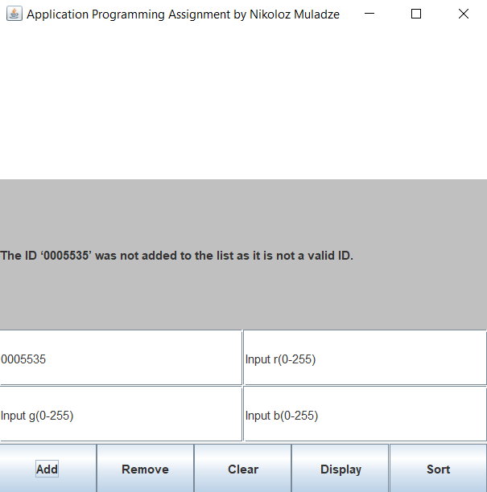

**Part 2: (Colors)**

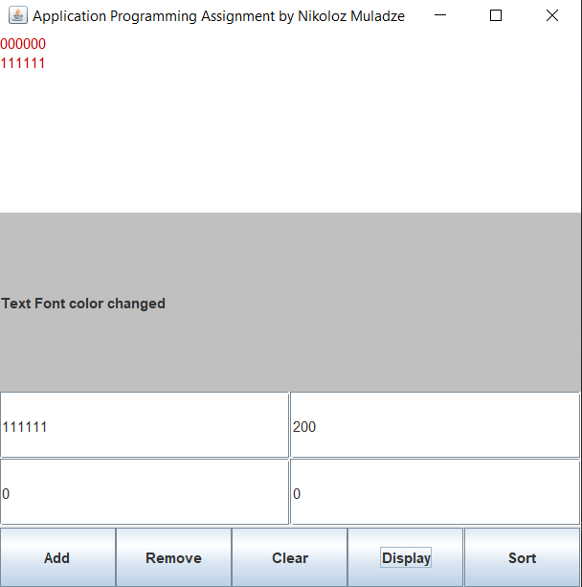

Action performed: added 111111 & 000000 to the list, typed in 200, 0, 0 in the next text fields

Which stand for RGB(), in this case we have RGB(200, 0, 0), which is a red color, after pressing Display button Text Color changes to red

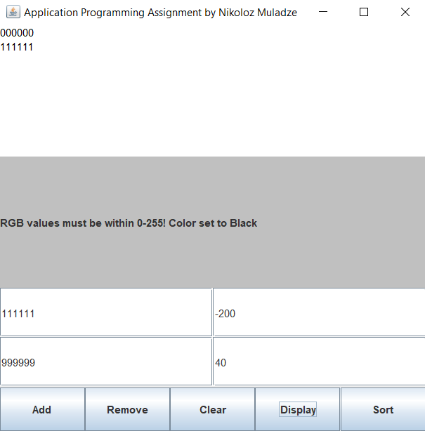

Action performed: typed in values lower than 0 and greater than 255, which then outputted an error and changed color back to black.